Widgets Lab 2

In this exercise, you’ll modify an application that uses a timer to display the elapsed minutes and seconds in a text box so it displays the elapsed time in a Progressbar widget. Estimated time: 10 to 15 minutes to research the widget and another 10 to 15 minutes to implement the changes.

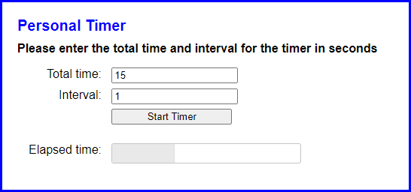

1. Open the personal_timer file

2. Run this application and test it. When you enter a total time and interval and click the Start Timer button, note that the elapsed minutes and seconds are displayed in a text box and are updated each time the interval passes.

3. Go to the jQuery UI website at https://jqueryui.com and display the documentation for the Progressbar widget. Review the code for one or more of the examples, then review the API documentation.

4. Modify the HTML for the application so it uses a Progressbar widget to display the elapsed time instead of a text box. Be sure to give the widget an id of “progressbar” so the CSS for the application works correctly.

5. Add a statement to the JavaScript file that activates the widget with a starting value of 0.

6. Modify the code that’s executed if the two entries are valid so it uses the widget. When you do that, you can delete the code that calculates and displays the elapsed minutes and seconds since it’s no longer needed. Then, you can add code that calculates and changes the value of the Progressbar widget